INSTITUTIONAL PROGRAM REVIEW 2011-12
Program Efficacy

Purpose of Institutional Program Review

Welcome to the Program Efficacy phase of the San Bernardino Valley College Program Review process. Program Review is a systematic process for evaluating programs and services annually. The major goal of the Program Review Committee is to evaluate the effectiveness of programs, (comma not needed here) and to make informed decisions about budget and other campus priorities.

The Institutional Program Review Committee is authorized by the Academic Senate to develop and monitor the college Program Review process, receive unit plans, utilize assessments as needed to evaluate programs, recommend program status to the college president, identify the need for faculty and instructional equipment, and interface with other college committees to ensure institutional priorities are met.

The purpose of Program Review is to:
❑ Provide a full examination of how effectively programs and services are meeting departmental, divisional, and institutional goals
❑ Aid in short-range planning and decision-making
❑ Improve performance, services, and programs
❑ Contribute to long-range planning
❑ Contribute information and recommendations to other college processes, as appropriate
❑ Serve as the campus’ conduit for decision-making by forwarding information to or requesting information from appropriate committees

Our Program Review process is two-fold. It includes an annual campus-wide needs assessment in the fall, (comma not needed here)and an in-depth review of each program every three years that we call the Program Efficacy phase. Instructional programs are evaluated the year after content review, and every three years thereafter, and other programs are placed on a three-year cycle by the appropriate Vice President.

An team of three disinterested committee members will meet with you to carefully review and discuss your document. You will receive detailed feedback regarding the degree to which your program is perceived to meet institutional goals. The rubric that the team will use to evaluate your program is included with this e-mail

When you are writing your program evaluation, you may contact efficacy team assigned to review your department or your division representatives for feedback and input. The list of readers is being sent to you with these forms as a separate attachment.

Completed documents should be sent to, Program Review Co-Chairs and your Division Dean by November 2, 2011. It is the writer’s responsibility to be sure the Committee receives the forms on time.

In response to campus wide feedback that program review be a more interactive process, the committee piloted a new program efficacy process in Spring 2010 that included a review team who will interview and/or tour a program area during the efficacy process. Another campus concern focused on the duplication of information required for campus reports. The efficacy process now incorporates the Educational Master Plan One-Page Summary (EMP Summary) and strives to reduce duplication of information while maintaining a high quality efficacy process.

Program Efficacy, 2011/2012

Complete this cover sheet as the first page of your report.

Program Being Evaluated
Aeronautics

Name of Division
Applied Technology, Transportation and Culinary Arts

Name of Person Preparing this Report Extension
Kevin Kammer

Name of Department Members Consulted
Rob Hesseltine, James Hoyt, Thomas Teeguarden

Name of Reviewers
Celia Huston, Sandra Waters, Kathy Kafela

Work Flow | Due Date | Date Submitted
Date of initial meeting with department
Rough Draft submitted to Program Review Team | 10/19/11
Report submitted to Program Review Team | 11/02/11

Staffing
List the number of full and part-time employees in your area.
Classification | Number Full-Time | Number Part-time, Contract | Number adjunct, short-term, hourly
Managers
Faculty | 1 |  | 5
Classified Staff |  | 1
Total | 1 | 1 | 5

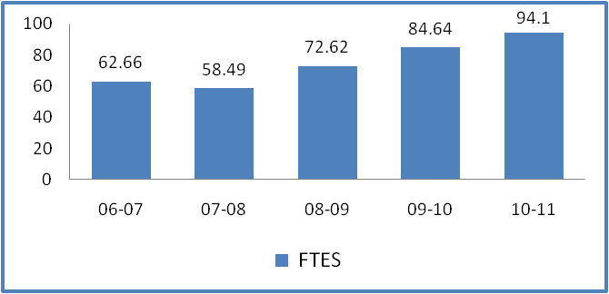

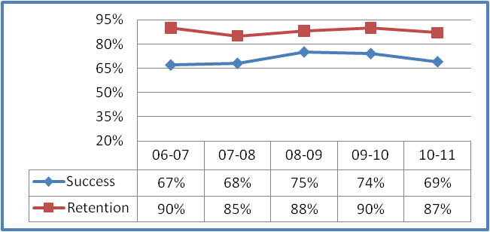

 | FTES |  |  |  | Chart 1
06-07 | 62.66
07-08 | 58.49
08-09 | 72.62
09-10 | 84.64
10-11 | 94.1
 |  |  |  | Chart 2
 |  | 04-05 | 05-06 | 06-07 | 07-08 | 08-09 | 09-10 | 10-11
Duplicated Enrollment |  | 193 | 267 | 318 | 294 | 376 | 431 | 477
FTEF |  | 6.08 | 7.56 | 6.61 | 6.68 | 7.22 | 7.02 | 7.02
WSCH per FTEF |  | 263 | 271 | 284 | 263 | 302 | 362 | 402
 |  |  |  |  |  | Chart 3
 | Success | Retention
06-07 | 67% | 90%
07-08 | 68% | 85%
08-09 | 75% | 88%
09-10 | 74% | 90%
10-11 | 69% | 87%
 |  |  |  | Chart 4
 |  | 04-05 | 05-06 | 06-07 | 07-08 | 08-09 | 09-10 | 10-11
Sections |  | 13 | 17 | 19 | 19 | 21 | 20 | 20
% of online enrollment
Degrees awarded |  | 4 | 1 | 0 | 1 | 1 | 2
Certificates Awarded |  | 25 | 17 | 28 | 16 | 19 | 36
Data includes: SBVC, SOFF and SBBHS
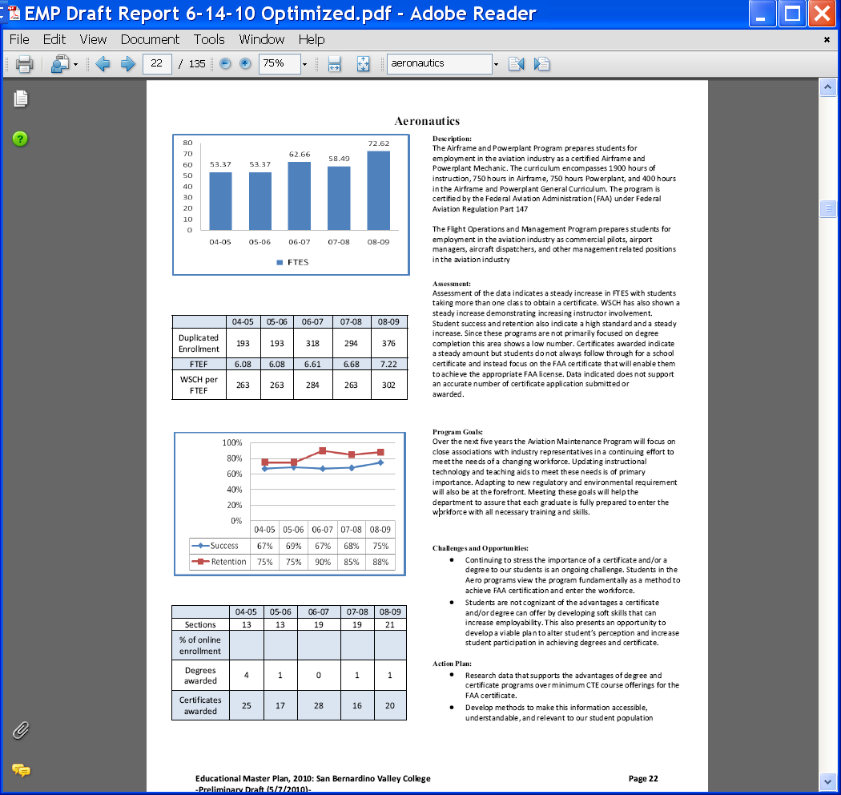Part
I. Questions Related to Strategic Initiative: Access

Use the demographic data provided to describe how well you are providing access to your program by answering the questions below.
Demographic Information
Strategic Initiative | Institutional Expectations
 | Does Not Meet | Meets
Part I: Access
Demographics | The program does not provide an appropriate analysis regarding identified differences in the program’s population compared to that of the general population | The program provides an analysis of the demographic data and provides an interpretation in response to any identified variance.  If warranted, discuss the plans or activities that are in place to recruit and retain underserved populations.
Pattern of Service | The program’s pattern of service is not related to the needs of students. | The program provides evidence that the pattern of service or instruction meets student needs.  If warranted, plans or activities are in place to meet a broader range of needs.

Aeronautics |  | Campus
11.40% | African-American | 18.55
2.07% | Asian | 4.42
0.00% | Native American | 0.74
0.00% | Pacific Islander | 1.35
0.00% | Filipino | 1.91
33.68% | Hispanic | 48.62
49.74% | White | 20.32
1.04% | Multi-Ethnicity | 1.35
2.07% | Unknown | 3.48
96.37% | % - Male | 41.4
3.63% | % - Female | 58.4

Does the program population reflect the college’s population? Is this an issue of concern? If not, why not? If so, what steps are you taking to address the issue?

In most areas the Aeronautics Department student population reflects the college’s diversity. One of the main differences is in gender percentage. The Aeronautics program lends itself mainly to males due to the heavy lifting and more physically strenuous requirements of the program. Another factor is the pervasive view of the industry that aviation is a male oriented career. This is being addressed from a industry standpoint by trade magazines and marketing and human resource development by the industry itself .The department has committed to recruiting females to the program with presentations at the local high schools, booths and recruitment activities at the Annual Route 66 Rendezvous along with the Aeronautics Advisory Committee, and the Wathen Foundation and their Aviation High School. These outreach and diversity promotion programs will be continued along with continuing exploration of similar community events and programs. New department brochures are being developed and an emphasis will be placed on graphic representation of women in these occupations. There is also a 14 percentage point difference in Hispanic enrollment when compared to the campus. This difference can be partially explained by students of this diversity tend to enroll in the program as a cohort, with some years a group will enroll in a program , and a following year a cohort will not be developed. There is also a 29% difference between African-American and white students. This can be partially explained by small class numbers and the effect of several students skewing the diversity numbers. This diversity is also prevalent in the industry. Trade associations have reflected on this ethnic employment imbalance and have called upon industry to promote the merits of the industry with advertising programs targeted at various ethnic groups.(PAMA) (AMT) Data suggest that Industry norms are reflected in the Aeronautics program population. Current Population Survey 2011 data from the Bureau of Labor Statistics shows 1.2% of Aircraft and avionics technicians are Female; 7.1 % African American and 15.3% are Hispanic. http://www.bls.gov/cps/cpsaat11.pdf. The students with disabilities percentage are lower than the campus average since the nature of the program does not lend its self well to students with certain physical disabilities.

Pattern of Service
How does the pattern of service and/or instruction provided by your department serve the needs of the community? Include, as appropriate, hours of operation/pattern of scheduling, alternate delivery methods, weekend instruction/service.

Our Airframe and Powerplant Maintenance curriculum is offered only in the daytime. One reason is that there is not enough laboratory space and equipment availabile. Students have specified lab projects that are mandatory from the FAA. There is only so much space and laboratory equipment that is available and it would be very difficult to operate both an evening and day class due to this reason. Another reason is that a student is required to attend classes for the FAA mandated hours of instruction to receive a certificate. To complete these hourly requirements in a reasonable amount of calendar time with a evening offering would extend the program to a 3-4 year program. Our Flight Operations and Management classes are primarily offered in the evening because this is when our student population is available. We have previously offered both day and evening classes as recent as 2008 and enrollment was markedly higher in the evening classes. The curriculum used in the Flight Operations and Management program is certified by the FAA under Federal Aviation regulation Part 141. It is approved for delivery in specified hourly increments and is not adaptable for delivery on the weekends or in an on-line instructional format.

Part II: Questions Related to Strategic Initiative: Student Success
Strategic Initiative | Institutional Expectations
 | Does Not Meet | Meets
Part II: Student Success - Rubric
Data demonstrating achievement of instructional or service success | Program does not provide an adequate analysis of the data provided with respect to relevant program data. | Program provides an analysis of the data which indicates progress on departmental goals.  If applicable, supplemental data is analyzed.
Student Learning Outcomes and/or Student Achievement Outcomes | Program has not demonstrated that they have made progress on Student Learning Outcomes (SLOs) and/or Service Area Outcomes (SAOs) based on the plans of the college since their last program efficacy. | Program has demonstrated that they have made progress on Student Learning Outcomes (SLOs) and/or Service Area Outcomes (SAOs) based on the plans of the college since their last program efficacy.

Provide an analysis of the data and narrative from the program’s EMP Summary and discuss what it reveals about your program. (Use data from the Charts 3 & 4 that address Success & Retention and Degrees and Certificates Awarded” on page 3 of this form.)
The data indicates that in the area of student success the program has seen a small but steady increase between academic school years 06/07 and 10/11. There was a spike in success in 08-10 academic school year which can be attributed to a cohort of students working with each other in the 2 year program to help with each other’s success. This cohort was developed by a group of students who developed the idea independent of the program. Research was gathered by this cohort and they decided to attend the program a s a group and help each other. We would like to continue and promote more students with this cohort idea of education. The current economic climate has increased our student’s financial issues, and as a result they realize the need to succeed and make additional effort to achieve student success. Another factor is that the instructors have learned to recognize at an early time period students that are at risk of failure and can undertake remedial action.

The student retention level is a mixed message that showed several decreases and increases. From a high of 90% retention to a decrese to 88% retention can be accounted for in several ways. One method is the overall size of the class is small and the net result of a few students can skew the data to show a marked increase or decrease in retention. Another issue that we feel has affected retention and success data in the recent data reporting years is the continued economic outlook. Students are going back to school and since class offerings are reduced the students are taking classes to meet minimum requirements for financial aid and do not appear to be as concerned about success. Overall the Aero Departments retention is appreciably higher than the campus rate. Students in this program tend to stay enrolled as long as it does not interfere with an employment opportunity. If the financial need is too great students will seek employment rather than completing a program or section and benefiting from its long term prospect of higher wages and continued employment. This data is gathered from case by case follow up by the instructor in each class or program.

One of the goals of the department is to increase retention by insuring students are aware of the benefits of completing all sections of the Aeronautics technology program. One method of working toward this goal can be accomplished by the instructors explaining the benefits of completing all sections of the program for an institutional certificate instead of one or two classes that can enable a student to find entry level employment. Requesting campus counselors to present to a class or cohort explaining the added benefits of completing a program will also be a method used to increase retention.
The certificates awarded by the campus do not reflect the true success of the program. The certificate awarded to a student by the college who has completed the program does not qualify the student to take the FAA written, oral, and practical examinations..It is awarded for completion of college credit which is a valuable asset but does not replace the certificate awarded by the department which enables the student to apply for the FAA issued A&P certificate. As a result students are less likely to even apply for the campus awarded certificate unless prompted by aeronautics program faculty members. This can have an adverse affect on the number of certificates awarded by the campus to the number of aeronautics students eligible for a certificate.

Supplemental Data
Provide any additional information, such as job market indicators, standards in the field or licensure rates that would help the committee to better understand how your program contributes to the success of your students.
Job market related to their majors or certificates: (resource: CC Benefits) | Some of the positions available are Airframe Mechanic, Powerplant Mechanic, Airframe and Powerplant Mechanic, Sheet Metal worker, Structural Assembler, Inspector in many different industries. Commercial Pilots, Aircraft Dispatchers, Aviation management positions, Support personnel.
Standards in the field | Our program is certified by the Federal Aviation Administration which holds our programs to very stringent standards. We try to always exceed these standards which results in our graduates in many cases becoming the supervisors or lead persons in the industry.
Labor and other statistics (national, western states, regional) www.labormarketinfo.edd.ca.gov | For California projected between 2004-2014:  Aircraft Mechanics 13,300, increase 14.7%  Installation Maintenance. and Repair 25,600, increase 18%  Sheet Metal Workers 24,200 increase 21%  Airline Pilots 7,600, increase 18.8%  The overall outlook for aircraft Mechanics should be favorable over the next 10 years. The small number of young workers in the labor force, coupled with a large number of retirements, point to good employment conditions for students just beginning training
Comparison colleges

Job Placement | With the current economic situation our state is in our graduates have several choices of employment. Industry oriented job opportunity marketing publications are available as well as information from our advisory committee members and associates.
Licensure rates | Our Licensure rate, or as the FAA specifies, certificates, over the past has been nearly 100%.
Advisory Committee Recommendations | Our Advisory Committee meets on a monthly to bi-monthly basis during the school year and actively supports our programs. The committee has stressed the need for people in the A&P and Aviation management areas,

The Aeronautics program has been consistently in the top 10 (18+ Units) Awarded for the Campus

Student Learning Outcomes and/or Student Area Outcomes
Demonstrate that your program has continued to make progress on Student Learning Outcomes (SLOs) and/or Service Area Outcome (SAOs) based on the plans of the college since the program’s last efficacy report.
See Strategic Initiative 5.1

. The Aeronautics Department has completed all section SLO’s, certificate and degree SLO’s. Progress is being made in the continuous cycle of student and program improvement from assessment information for implementation of changes needed to improve student learning. The program has continued in updating SLO’s that reflect more accurately the learning outcome of a specific class. This continuous improvement cycle is ongoing within the program.

Part III. Questions Related to Strategic Initiative: Institutional Effectiveness
Strategic Initiative | Institutional Expectations
 | Does Not Meet | Meets
Part III: Institutional Effectiveness - Rubric
Mission and Purpose | The program does not have a mission, or it does not clearly link with the institutional mission. | The program has a mission, and it links clearly with the institutional mission.
Productivity | The data does not show an acceptable level of productivity for the program, or the issue of productivity is not adequately addressed. | The data shows the program is productive at an acceptable level.
Relevance, Currency, Articulation | The program does not provide evidence that it is relevant, current, and that courses articulate with CSU/UC, if appropriate. | The program provides evidence that the curriculum review process is up to date. Courses are relevant and current to the mission of the program.  Appropriate courses have been articulated or (?) transfer with UC/CSU or plans are in place to articulate appropriate courses.

Mission and Purpose:
SBVC Mission: San Bernardino Valley College provides quality education and services that support a diverse community of learners.
What is the mission statement of the program?
Our purpose is to give a diverse group of students the knowledge and skills necessary to successfully gain employment in the aviation industry and give them the foundation necessary to continue to learn and progress in their field of endeavor.

How does this purpose relate to the college mission?
San Bernardino Valley College provides quality education and services that support a diverse community of learners.
The Aeronautics Department’s program mirrors the mission of the college’s in aiming for the same goals of diversity, quality and educational accomplishment.

Productivity
Provide additional analysis and explanation of the productivity data and narrative in the EMP Summary, if needed. (Use data from charts 1 and 2 (FTEs; Enrollment; FTFE and WSCH per FTFE) on page 3 of this form). Explain any unique aspects of the program that impact productivity data for example; Federal Guidelines, Perkins, number of workstations, licenses etc…
Overall FTES has increased from the 04-05 academic year of 53.7, to the 10-11 academic year FTES of 94.1 a difference of 40 which is a 75% change. This change can be partially attributed to the continued economic improvement of the commercial airline industry after 9/11, and the improved public perception of the industry as a technologically advanced career field, dispelling a broader held opinion of a “greasy mechanic” field of employment . 07-08 and a spike in 08-09..
FTFE data has been increasing fairly steadily, increasing to a high of 7.22 FTEF for the 07-08 academic year, representing a 15% increase over a 5 year period. One factor that can limit productivity is the laboratory environment which has a limited capacity for students and a FAA mandated student to instructor population.

Relevance and Currency, Articulation of Curriculum
If applicable to your area, describe your curriculum by answering the following questions.
The Content Review Summary from Curricunet indicates the program’s current curriculum status. If curriculum is out of date, explain the circumstances surrounding the error and plans to remedy the discrepancy.
Applied Technology, Transportation & Culinary Arts
Aeronautics
 | Course | Status | Last Content Review | Next Review Date
 | AERO015 Basic Fundamentals of Aircraft Composite Structures | Active | 04/09/2007 | 04/09/2013
 | AERO098 Aeronautics Work Experience | Active | 12/07/2009 | 12/07/2015
 | AERO100.1 Airframe and Powerplant General Calculations | Active | 11/15/2005 | 11/15/2011
 | AERO100.2 Airframe and Powerplant General Publications | Active | 11/15/2005 | 11/15/2011
 | AERO101.1 Airframe and Powerplant General - Materials | Active | 11/15/2005 | 11/15/2011
 | AERO101.2 Airframe and Powerplant General - Servicing | Active | 11/15/2005 | 11/15/2011
 | AERO102 Airframe Maintenance Lecture - Structures | Active | 11/15/2005 | 11/15/2011
 | AERO103 Airframe Maintenance Lecture - Systems and Components | Active | 11/15/2005 | 11/15/2011
 | AERO104 PwrPlnt Maint Lec-Rcp Eng Ovh | Active | 11/15/2005 | 11/15/2011
 | AERO105 Powerplant Maintenance Lecture - Accessory Overhaul | Active | 11/15/2005 | 11/15/2011
 | AERO106.1 Airframe and Powerplant General Laboratory - Calculations | Active | 11/15/2005 | 11/15/2011
 | AERO106.2 Airframe and Powerplant General Laboratory - Publications | Active | 11/15/2005 | 11/15/2011
 | AERO107.1 Airframe and Powerplant General Laboratory - Materials | Active | 11/15/2005 | 11/15/2011
 | AERO107.2 Airframe and Powerplant General Laboratory - Servicing | Active | 11/15/2005 | 11/15/2011
 | AERO108 Airframe Maintenance Laboratory - Structures | Active | 11/15/2005 | 11/15/2011
 | AERO109 Airframe Maintenance Laboratory - Systems and Components | Active | 11/15/2005 | 11/15/2011
 | AERO110 Powerplant Maintenance Laboratory - Reciprocating Engine Overhaul | Active | 11/15/2005 | 11/15/2011
 | AERO111 Powerplant Maintenance Laboratory - Accessory Overhaul | Active | 11/15/2005 | 11/15/2011
 | AERO121 Aviation Fundamentals | Active | 04/09/2007 | 04/09/2013
 | AERO122 Private Pilot Ground School | Active | 10/04/2010 | 10/04/2016
 | AERO124 Aircraft Powerplants | Active | 10/23/2006 | 10/23/2012
 | AERO125 Flight Safety | Active | 10/09/2006 | 10/09/2012
 | AERO126 Aircraft Structures | Active | 10/23/2006 | 10/23/2012
 | AERO134 Civil Aviation Management and Laws | Active | 10/23/2006 | 10/23/2012
 | AERO140 Instrument Ground School | Active | 10/04/2010 | 10/04/2016
 | AERO144 Aviation Weather | Active | 04/09/2007 | 04/09/2013
 | AERO100.1 Airframe and Powerplant General Calculations | Pending | 11/15/2005 | 11/15/2011
 | AERO100.2 Airframe and Powerplant General Publications | Pending | 11/15/2005 | 11/15/2011
 | AERO101.1 Airframe and Powerplant General - Materials | Pending | 11/15/2005 | 11/15/2011
 | AERO101.2 Airframe and Powerplant General - Servicing | Pending | 11/15/2005 | 11/15/2011
 | AERO102 Airframe Maintenance Lecture - Structures | Pending | 11/15/2005 | 11/15/2011
 | AERO103 Airframe Maintenance Lecture - Systems and Components | Pending | 11/15/2005 | 11/15/2011
 | AERO104 Powerplant Maintenance Lecture - Reciprocating Engine Overhaul | Pending | 11/15/2005 | 11/15/2011
 | AERO105 Powerplant Maintenance Lecture - Accessory Overhaul | Pending | 11/15/2005 | 11/15/2011
 | AERO106.1 Airframe and Powerplant General Laboratory - Calculations | Pending | 11/15/2005 | 11/15/2011
 | AERO106.2 Airframe and Powerplant General Laboratory - Publications | Pending | 11/15/2005 | 11/15/2011
 | AERO107.1 Airframe and Powerplant General Laboratory - Materials | Pending | 11/15/2005 | 11/15/2011
 | AERO107.2 Airframe and Powerplant General Laboratory - Servicing | Pending | 11/15/2005 | 11/15/2011
 | AERO108 Airframe Maintenance Laboratory - Structures | Pending | 11/15/2005 | 11/15/2011
 | AERO109 Airframe Maintenance Laboratory - Systems and Components | Pending | 11/15/2005 | 11/15/2011
 | AERO110 Powerplant Maintenance Laboratory - Reciprocating Engine Overhaul | Pending | 11/15/2005 | 11/15/2011
 | AERO111 Powerplant Maintenance Laboratory - Accessory Overhaul | Pending | 11/15/2005 | 11/15/2011
 | AERO011 Power Plant Maintenance Review | Historical
 | AERO011 Power Plant Maintenance Review | Historical
 | AERO013 Airframe Maintenance Review | Historical
 | AERO013 Airframe Maintenance Review | Historical
 | AERO015 Bsc Fndmtls Aircft Cmpst Strut | Historical
 | AERO122C FAA Private Pilot Ground School | Historical
 | AERO122D FAA Private Pilot Ground School | Historical
 | AERO131B Privt Cmmrcl Pilot Grnd School | Historical
 | AERO131B Privt Cmmrcl Pilot Grnd School | Historical
 | AERO140C Instrument Ground School and Flight Simulators | Historical
 | AERO140D Instrument Ground School and Flight Simulators | Historical
 | AERO144 Aviation Weather | Historical

Currently all section of AERO are under curriculum review except Aero 122 and Aero 140 which completed the review process in 2010. This is a total of 32 sections. All sections have been forwarded to the curriculum committee and are currently under review.

Articulation and Transfer
List Courses above 100 where articulation or transfer is not occurring | With CSU | With UC

Describe your plans to make course qualify for articulation or transfer.
Our courses are accepted for credit at various institutions. Cal Poly Pomona has recognized these courses for credit in their educational programs, San Jose State, Southern Illinois University, and Embry–Riddle Aeronautical University also recognize these classes for transfer credit.

Currency
Follow the link below and review the last college catalog data.
http://www.valleycollege.edu/academic-career-programs/college-catalog.aspx
Is the information given accurate? Which courses are no longer being offered? (Include Course # and Title of the Course). If not, how does the program plan to remedy the discrepancy?
AERO 124 Aircraft Power Plants 3
AERO 125 Flight Safety 2
AERO 126 Aircraft Structures 3
AERO 134 Civil Aviation Management and Laws 3
AERO 144 Aviation Weather 3
These classes are not currently being offered due to budget constraints. They are in the curriculum review process and we hope to offer these sections as the financial situation of the campus improves

Part IV. Planning
Strategic Initiative | Institutional Expectations
 | Does Not Meet | Meets
Part IV: Planning - Rubric
Trends | The program does not identify major trends, or the plans are not supported by the data and information provided. | The program (hyphen not needed here—oops—it looks like a deletion lineidentifies and describes major trends in the field. Program addresses how trends will affect enrollment and planning. Provide data or research from the field for support.
Accomplishments | The program does not incorporate accomplishments and strengths into planning. | The program incorporates substantial accomplishments and strengths into planning.
Challenges | The program does not incorporate weaknesses and challenges into planning. | The program incorporates weaknesses and challenges into planning.
What are the trends, in the field or discipline, impacting your student enrollment/service utilization? How will these trends impact program planning?
The Bernardino Valley College Aeronautics Department Aviation Maintenance Program is a FAA approved Part 147 school. This is the Federal governments method of accrediting our Aviation Maintenance Technician program as a approved institution to provide instruction and issue certificates that are recognized universally across the nation for a student to complete the FAA examination to become a Airframe & Powerplant technician (A&P). A trend recognized over the past several years is that the number of Part 147 educational facilities has decreased due to budget issues and a reprioritization of available assets. Some opponents of the programs state that it would be better if the “for profit” institution handled the increased demand for trained technicians. If this trend continues a large segment of society will be either “shut out” of aviation maintenance training or be burdened with large amounts of debt. This could impact our program by creating a need for added sections and additional full time instructors. We are partnering with several national aviation employment companies (FedEx, SkyWest Airlines, Wathen Aviation Foundation) to develop internship programs to continue to provide employers with a well trained workforce and also show students that this career field is a viable and increasingly active employment opportunity. Programs to accommodate additional students are in the developmental stages.
Another trend in the industry is that human resource data from national aviation maintenance companies indicate that a large portion of the maintenance workforce (40%) will be retiring in the next 5-10 years. This information is from our aeronautics advisory committee members and from industry trade publications. These companies have discussed the potential maintenance technician shortfall with fellow members of the aero advisory committee members. Efforts to address the issue have been introduced and evaluated by the Federal Aviation Administration (FAA) which has formed a task force and a nationwide advertising campaign to promote aviation careers. This advertising promotion can be customized for use by individual institution to specifically target local population. We plan to utilize all available promotional materials from available sources. Southern California Logistics Airport has launched an advertising campaign to promote aviation careers, Airframe and Powerplant Mechanics in particular, because the demand is growing so fast that even with nationwide searches they cannot meet the demand.
Pilots are also in short supply. The FAA has allowed the increase of the mandatory retirement age because of the shortage of qualified pilots. This is due to cohorts of pilots that generally enter the workforce following the completion of international conflicts around the world. Basically, there is an influx of trained pilots after a war or conflict. This was true after the Korean conflict, Vietnam, and Desert Storm. This trend has changed and the military is “holding on” to their trained pilots and fewer are entering commercial aircraft service as a civilian pilot. This has led to a pilot shortage. The raising of the age is a relatively short term fix and the industry has recognized the need for a new source of trained pilots. This shortage is not just in pilots, but also who will train the next generation of pilots? One of our graduates who works for Fed-Ex shared and article out of an internal Fed-Ex newsletter stating that in the next two to three year they will be losing 30% of their pilots due to retirements. Some of the local Flight Schools are stating that they are having a difficult time finding flight instructors. We plan to offer additional sections in our Aviation Flight Operations program and are planning to upgrade the flight training simulators with current generation technology. Additional training media, classroom and laboratory instructional aides, and continued instructor professional development are also planned.

Accomplishments and Strengths
Referencing the narratives in the EMP Summary, provide any additional data or new information regarding the accomplishments of the program, if applicable. In what way does your planning address accomplishments and strengths in the program?

The Aeronautics program has worked toward acquisition of and employment of the latest technology currently available in the aerospace industry for and maintenance training in the classroom and the laboratory. This enables our graduates to enter the workforce with the latest technology training available at this time. Acquisition of a late generation JT8D turbofan engine as a donation from Federal Express is an example of the training equipment utilized. Working closely with industry has led us to focus in on emerging technology that industry is embracing, and example is the Basic Composites Technology course offering. This enables students to have a more advanced understanding of composite structures technology, and how to maintain and repair them, that is used in an aircraft that is only now entering service, the Boeing 787 Dreamliner.

Challenges
Referencing the narratives in the EMP Summary, provide any additional data or new information regarding planning for the program. In what way does your planning address trends and weaknesses in the program?
The industry is continuing development in all aspect of aircraft technology, including aircraft structures, avionics, control, emerging Powerplant technology and troubleshooting systems. This is a plus for the end user with an increase in passenger comfort, reduced cost, and increased safety Unfortunately this requires continual improvement in the training equipment and technology in our program. This requires more planning and development of strategies to not just keep up, but stay ahead of what the industry needs in regards to training, knowledge, and skill levels, for new employees entering the workforce. A primary method to improve in this area is specialized computer based troubleshooting simulators and software.
The aviation maintenance program at SBVC has 5 primary training aircraft. The average age of these aircraft’s date of manufacture is 1955. This place there average age at well over 50 years old. This is a major challenge to provide instruction that is current with aircraft of this age. The phased replacement of these aircraft is a must to maintain a level of currency. Continued partnering with Advisory members and industry representative is one way that we can start to modernize and improve our primary training aircraft. Donation of modern aircraft and funding from grants is also being explored.
Planning needs to address keeping students in the program for completion of certificates. This will help students qualify for higher paying positions instead of “outing” the program at the first available employment opportunity. Communication plans need to be developed to address this issue. One approach we will develop is to survey the students to better determine their needs and issues preventing completion. Another plan is to communicate to the students through the institutions counselor program that completing an institutional certificate will benefit a student with a well rounded education that can benefit in a much wider field of employment and room for greater advancement in the workforce. The benefit of working toward a certificate that is offered by the institution instead of the instructional certificate offered by the instructors is another area that can be communicated to the students through statistics and data from the Labor Department. This will give a program graduate all the tools to succeed in the workforce with an approved institutional certificate with the full backing of the institution.
Aircraft Powerplant Technology is rapidly evolving. With the advent of “green” technology in diesel engines and reciprocating avgas powered engines the need for training on these engines is increasing. The primary training reciprocating engine in the Aircraft Powerplant Technologies program at SBVC is a design that was first created in 1939. The ability to offer instruction on engines that are based on 60+ year old design is very limited. The program needs new engine trainers that in corporate FADEC (Full Authority Digital Engine Control) systems and advanced emission control system. This will help ensure our graduates are fully prepared to enter the workforce trained on current generation technology. Planning needs to address a phased replacement of older technology and implementation of current training technology.

The composites repair technology will experience rapid growth in industry due to emerging technologies and the industry trend to develop lighter and more fuel efficient aircraft. Planning needs to recognize this growth and develop appropriate offerings to meet the need. Our composites class is a start but additional equipment, vacuum bagging, hot bonders are necessary to keep pace with this emerging technology. Development of a advanced composite program is in the planning stages.
The negative media publicity concerning the aviation industry after 911 that continued for years has hindered our programs. It is just recently that it has started to decrease. The public’s view of aviation and the media publicity concerning any kind of aviation incident has a lasting impact. The fact that a large number of the high schools have eliminated or reduced their career technical education programs has hindered all career technical education programs. Industry has recognized that there is a pattern developing that indicates a growing need for skilled technicians in all workforce areas and the most proactive are developing plans to remedy the situation. The Aero program needs to be ready to meet these upcoming challenges. Planning to improve outdated training equipment and training aids, additions in CBT technology, professional development is a priority.

V. Questions Related to Strategic Initiative: Technology, Campus Climate and Partnerships.
Part V: Technology, Partnerships & Campus Climate
 | Program does not demonstrate that it incorporates the strategic initiatives of Technology, Partnerships or Campus Climate.  Program does not have plans to implement the strategic initiatives of Technology, Partnerships or Campus Climate | Program demonstrates that it incorporates the strategic initiatives of Technology, Partnerships and/or Campus Climate.  Program has plans to further implement the strategic initiatives of Technology, Partnerships and/or Campus Climate.

Describe how your program has addressed the strategic initiatives of technology, campus climate and/or partnerships. What plans does your program have to further implement these initiatives.
For a positive campus climate we have several opportunities. Our graduates are well trained and have been good ambassadors for the department and the college. We stress safety very heavily to all of our students through extensive safety briefings and on a daily basis. Our program has an excellent reputation in the aviation industry for quality instruction. We maintain a safe environment for our students to work in. We try to keep our classroom and lab areas cleans and neat so that those coming to tour our area will have a good impression of our portion of the campus. Our aircraft and flight simulators are always an area of interest for K-12 students and others touring our campus. Our instructors have developed excellent reputations in the aviation and education communities. To continue and reinforce these opportunities will be a positive contribution to the campus climate. As previously mentioned we have developed ongoing partnerships with industries that are associated with our Advisory Committee. We will continue to work with them in developing internships and exchange of knowledge concerning industry needs and trends.

